**CP LAB**

LAB 7

NAME: **AYESHA ARSHAD**

ENROLLMENT: **01-131232-018**

SECTION: **BSE 1B**

DEPARTMENT OF SOFTWARE ENGINEERING

BAHRIA UNIVERSITY ISLAMABAD

**Task 1**

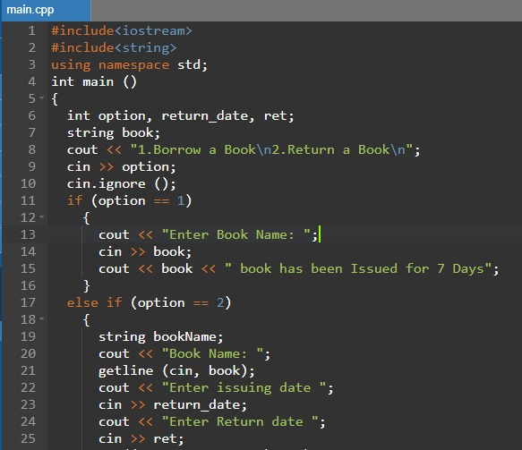

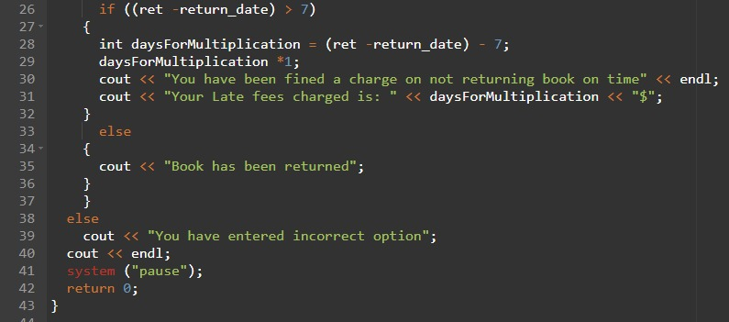

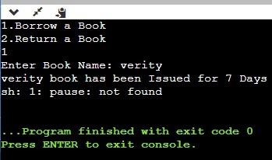

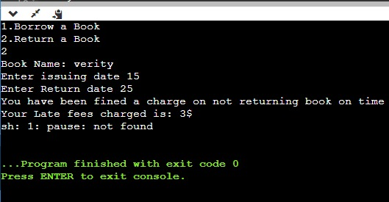

**Task 2**



